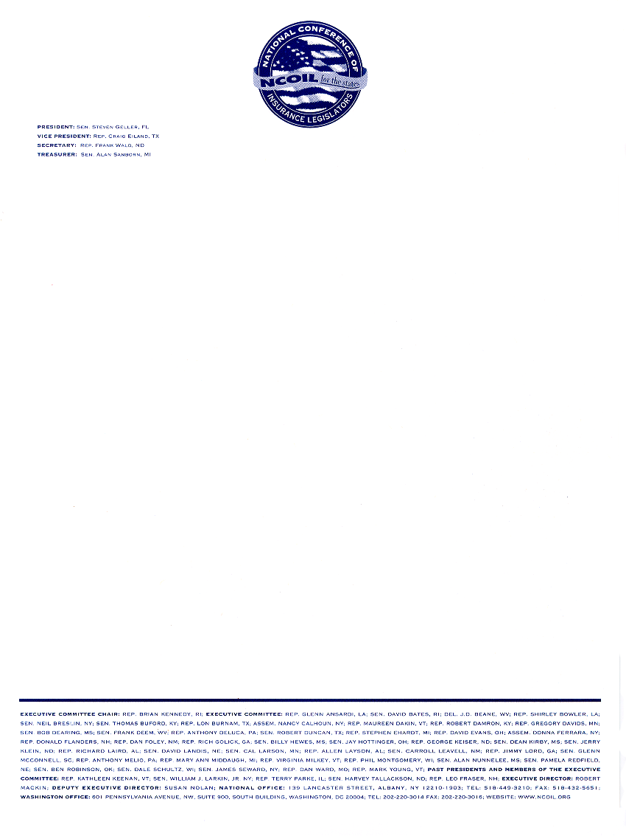
NATIONAL CONFERENCE OF INSURANCE LEGISLATORS
RESOLUTION IN SUPPORT OF THE EXTENSION OF THE TERRORISM RISK INSURANCE ACT OF 2002
Adopted by the NCOIL Terrorism Insurance Task Force on July 15, 2004.
Adopted by the NCOIL Executive Committee on July 16, 2004.

WHEREAS, the United States continues to be engaged in an ongoing war against international terrorists and the threats of future attacks inside the country remains high; and
WHEREAS, future attacks could include the use of nuclear, biological, chemical or radiological weapons that could result in a large number of casualties; and
WHEREAS, the Terrorism Risk Insurance Program, created through the enactment of the Terrorism Risk Insurance Act (TRIA) of 2002, has provided a viable terrorism risk insurance market for property and commercial losses; and
WHEREAS, absent extension by Congress, the Terrorism Risk Insurance Act of 2002 will expire on December 31, 2005; and
WHEREAS, failure by Congress to extend TRIA would likely result in the inability of insurers to offer coverage for future catastrophes resulting from terrorism; and
WHEREAS, without adequate terrorism insurance coverage, banks may be unwilling to extend loans for commercial transactions, such as mortgages, construction projects and other capital-intensive initiatives; and
WHEREAS, the lack of private terrorism insurance to cover losses from future terrorist attacks may require the federal government to cover such losses; and
WHEREAS, a federal backstop assures an available and affordable insurance market for America’s consumers and businesses; and
WHEREAS, without a backstop, a limited availability of insurance against terrorism would have a severe adverse effect on our country’s economy as financiers would be reluctant to lend, businesses would be reluctant to invest, and consumers would be unable to afford insurance; and
WHEREAS, NCOIL supported the enactment of the Terrorism Risk Insurance Act of 2002;
NOW, THEREFORE, BE IT RESOLVED, that NCOIL supports extension of the Terrorism Risk Insurance Act of 2002; and
NOW, THEREFORE, BE IT FURTHER RESOLVED, that NCOIL supports the inclusion of group life insurance in any extension legislation; and
NOW, THEREFORE, BE IT FURTHER RESOLVED, that NCOIL urges Congress and the Administration to take action as soon as possible to extend the Terrorism Risk Insurance Act of 2002.

